Planning Project Methodology Investigation Notes

**Waterfall vs Agile notes**

* Waterfall ideology is the more ‘traditional’ project planning approach. It has a linear approach to software development. The sequence of events is normally: Gather Requirements, Design, Development, Testing, Fix issues and then Delivery.
* The nature of my project is that I may not have a fixed time or scope as I will be simultaneously working on other projects so my time could vary dramatically
* . Waterfall makes it so that you lock down on a specific scope, removing the flexibility you have on adjusting requirements
* Projects that have constant requirement changes are more suitable for Agile methodology.
* So, using Agile to test and review regularly will ensure in a better product
* **Colleague advice** that helped my decision.

Videos that helped me:



Free Udemy course that gave a non-biased review of what is the most appropriate principle. This is a 2017 course so contains the most up to date practises for both principles.



Personal knowledge that I used that made me make decision. Had first-hand knowledge of Agile during placement year so another reason to use it.

**Trello Notes + Implementation**

<http://www.projectmanagers.net/i/the-pros-and-cons-of-trello/>

Pros:

* Free and easy to sign up
* Any screen. Easy on phone.
* Can see all items on page.
* Creating issues and assigned someone to those issues are simple and easy.

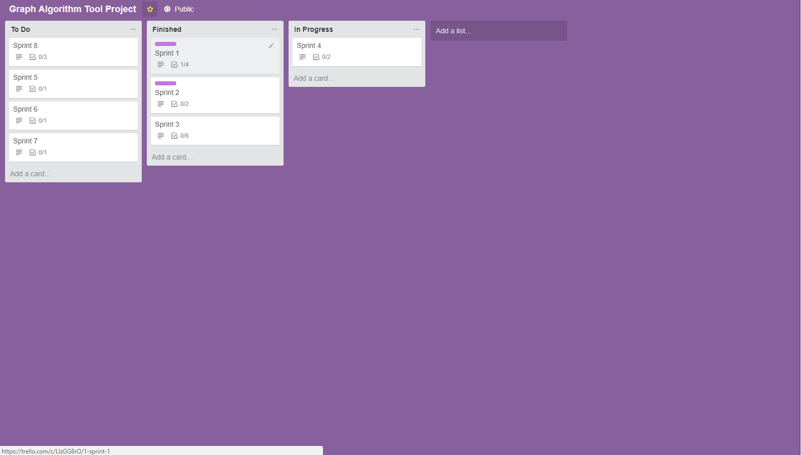

As my project is Agile, Trello works perfectly with this style. The reason being is if I have a story that needs to be added as an emergency in a sprint, this can be easily done with Agile. Unlike waterfall were everything is rigidly structured so added a story spontaneously can be an issue.